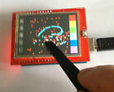**2.4" TFT LCD Shield + Touch Panel Display w/TF Reader for Arduino UNO**

The shield is fully assembled, tested and ready to go. No wiring, no soldering! Simply plug it in and load up our library - you'll have it running in under 10 minutes! Works best with any classic Arduino (UNO/Duemilanove/Diecimila). This shield does NOT work with the Mega Arduinos but its going to be half the speed of the Uno-type boards because of the way the Mega rearranges all the pins (there is no way to get around this!) This shield is not Leonardo-compatible

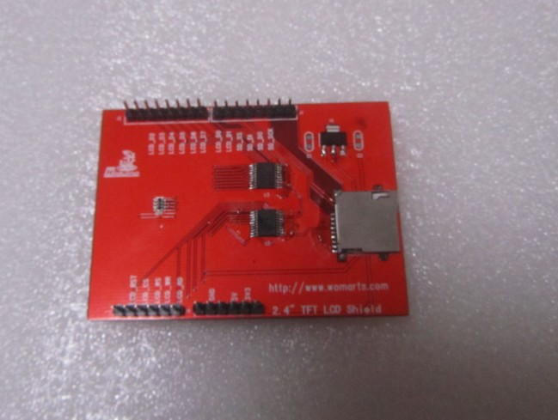 [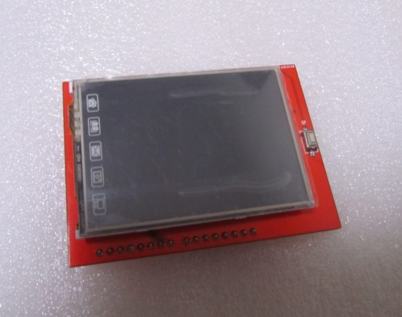](http://s1293.photobucket.com/user/lifenoteasy/media/2013-05-06_182528_zpsb18e3592.jpg.html)

[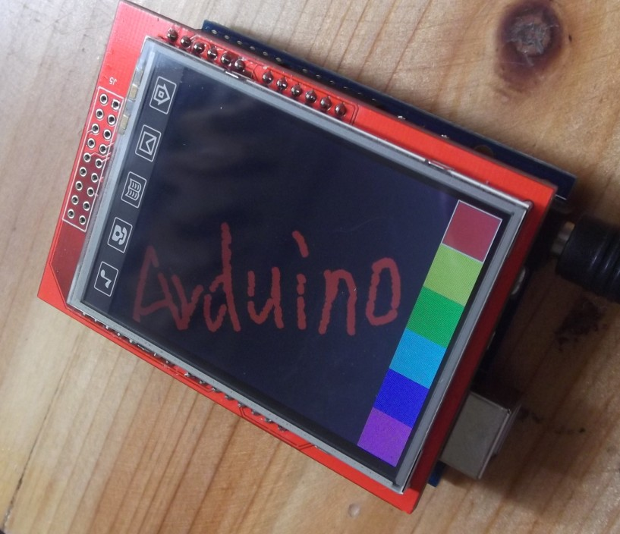](http://s1293.photobucket.com/user/lifenoteasy/media/2013-05-06_182528_zpsb18e3592.jpg.html)

Description:

Spice up your Arduino project with a beautiful large touchscreen display shield with built in microSD card connection. This TFT display is big (2.4" diagonal) bright (4 white-LED backlight) and colorful (18-bit 262,000 different shades)! 240x320 pixels with individual pixel control. It has way more resolution than a black and white 128x64 display. As a bonus, this display has a resistive touchscreen attached to it already, so you can detect finger presses anywhere on the screen.

Technical Details:

2.4" diagonal LCD TFT display

240x320 resolution, 18-bit (262,000) color

spfd5408 controller with built in video RAM buffer

8 bit digital interface, plus 4 control lines

Uses digital pins 5-13 and analog 0-3. That means you can use digital pins 2, 3 and analog 4 and 5. Pin 12 is available if not using the microSD

Works with any Arduino '328 or Mega (Leonardo not supported yet)

5V compatible! Use with 3.3V or 5V logic

Onboard 3.3V @ 300mA LDO regulator

4 white LED backlight. On by default but you can connect the transistor to a digital pin for backlight control

4-wire resistive touchscreen